CONSOLE APPLICATIONS

1) W.a.p addition, substraction, multiplication, division, of two integer numbers?

using System;
namespace using arithmetic operations
{
Class first
{
static void Main (string [] args)
{
int a, b, sum, substract, multiple, divide;
Console.WriteLine(“Enter integer number a”);
a=int.parse (Console.ReadLine ());
Sum=a+b;
Substract=a-b;
multiple=a*b;
divide=a/b;
Console.WriteLine(“sum of 2 integers”+sum);
Console.ReadLine();
Console.WriteLine(“substract of 2 integers”+substract);
Console.ReadLine();
Console.WriteLine(“multiple of 2 integers”+mul);
Console.ReadLine();
Console.WriteLine(“division of 2 integers”+div);
Console.ReadLine();
}
}
}

2) W.a.p to calculate volume of cone?

using System;
namespace using arithmetic operations
{
Class first
{
static void Main(string[] args)
{

Double r,h,v,pi=3.14;
Console.WriteLine(“Enter the value of r”);
r=double.parse(Console.ReadLine());

Console.WriteLine(“Enter the value of h”);
h=double.parse(Console.ReadLine());

v=1/3.0*pi*r*r*h;
Console.WriteLine(“the volume of cone=”+v);
Console.ReadLine();

}

3) W.a.p to calculate sum of digits?

using System;
namespace using arithmetic operations
{
Class first
{
static void Main(string[] args)
{

Int d1,d2,d3,sum=0,n;
Console.WriteLine(“Enter the 3 digit +ve integer number”);
n=int.Parse(Console.ReadLine());
d1=n%10;
n=n/10;
d2=n%10;
n=n/10;
d3=n%10;
n=n/10;
sum=d1+d2+d3;
Console.WriteLine(“sum is”+sum);
Console.ReadLine();
}

4) W.a.p to calculate simple interest?

using System;
namespace using arithmetic operations
{
Class first
{
static void Main(string[] args)
{

double p,n,r,si;
Console.WriteLline(“Enter the valoue of p”);
P=double.Parse(Console.ReadLine());

Console.WriteLline(“Enter the valoue of q”);
q=double.Parse(Console.ReadLine());

Console.WriteLline(“Enter the valoue of r”);
r=double.Parse(Console.ReadLine());

si=p*n*r/100;
Console.WriteLine(“simple interest is”+si)
Console.ReadLine();

}

5) W.a.p name is added to the whish message?

using System;
namespace using arithmetic operations
{
Class first
{
static void Main(string[] args)
{

String name;
Console.WriteLine(“Enter a person name”);
name=Console.ReadLine();
Console.WriteLine(“hai”+name+”happy new year”);
Console.ReadLine();
}

6) W.a.p which is the biggest value of the given number?

using System;
namespace using arithmetic operations
{
Class first
{
static void Main(string[] args)
{

int a,b;
Console.WriteLine(“Enter the first number”);
a=Console.ReadLine();

Console.WriteLine(“Enter the second number”);
b=Console.ReadLine();
if(a>b)
{

Console.WriteLine(“the biggest value is a”);
Console.ReadLine();
}
else
{
Console.WriteLine(“the biggest value is a”);
Console.ReadLline();
}

7) W.a.p to display the multiplication table?

using System;
namespace using arithmetic operations
{
Class first
{
static void Main(string[] args)
{

int n,i,k;
Console.WriteLine(“which table do u want”);
n=int.parse(Console.ReadLline());
for(i=1;i<=10;i++)
{
K=n*I;
Console.WriteLIne(“ “ + n + ” * ” + I + ” = ” + k + ” ”);
}
Console.ReadLine();
}

8) W.a.p if user enter the 3 subject marks and to check that student is passed or not?

using System;
namespace using arithmetic operations
{
Class first
{
static void Main(string[] args)
{

int s1,s2,s3;
Console.WriteLIne(“Enter the 1 subject marks”);
S1=int.Parse(Console.ReadLine());
Console.WriteLIne(“Enter the 2 subject marks”);
S2=int.Parse(Console.ReadLine());
Console.WriteLIne(“Enter the 3 subject marks”);
S3=int.Parse(Console.ReadLine());
If(s1 < 35 || s2 < 35 || s3 < 35)
{
Console.WriteLine(“he is failed”);
}
else
{
Console.WriteLine(“he is passed”);
}
Console.ReadLine();
}

9) W.a.p if user enters the hours, miniuts and seconds and to display the total number of seconds in that value?

using System;
namespace using arithmetic operations
{
Class first
{
static void Main(string[] args)
{
int h,m,s,total;
Console.WriteLine(“Enter hours”);
h=int.Parse(Console.ReadLine());

Console.WriteLine(“Enter hours”);
m=int.Parse(Console.ReadLine());

Console.WriteLine(“Enter hours”);
s=int.Parse(Console.ReadLine());

total=h*60*60+m*60+s;
Console.WriteLine(“the total time is”+total+” “);
Console.ReadLine();
}

10) W.a.p display the following series 1 2 4 8 16 32 --------1024?

using System;
namespace using arithmetic operations
{
Class first
{
static void Main(string[] args)
{

int i;
for(i=1;i<=1024;i=2*i)
Console.WriteLine(“ “ + i + “ “);
Console.ReadLine();
}
}

11) W.a.p to display the swapping of the given two numbers?

using System;
namespace using arithmetic operations
{
Class first
{
static void Main(string[] args)
{

int a,b;
Console.WriteLine(“Enter value of a”);
a=int.Parse(Console.ReadLine());

Console.WriteLine(“Enter value of b”);
b=int.Parse(Console.ReadLine());
a=a+b;
b=a-b;
a=a-b;
Console.WriteLine(“the value of a=”+a);
Console.ReadLine();
Console.WriteLine(“the value of a=”+b);
Console.ReadLine();
}

12) W.a.p if user enter the 3 digit number and to display its reverse number?

using System;
namespace using arithmetic operations
{
Class first
{
static void Main(string[] args)
{

int n,sum=0,r;
Console.WriteLine(“enter 3 digit number”);
n=int.Parse(Console.readLine());
while(n>o)
{
r=n%10;
sum=sum*10+r;
n=n/10;
}
Console.ReadLine(“the reverse number is “ +sum+ “ “);
Console.RadLine();
}

13) W.a.p to check the leap year or not?

using System;
namespace using arithmetic operations
{
Class first
{
static void Main(string[] args)
{
Int year;
Console.WriteLine(“Enter the year”);
Year=int.Parse(Console.ReadLine());
If(year % 4 !=0)
Console.WriteLine(“it is not a leap year”);
else
if(year % 100 != 0)
Console.WriteLine(“it is not a leap year”);
else
If(year % 400 ==0)
Console.WriteLine(“it is a leap year”);
else
Console.WriteLine(“it is not a leap year”);
Console.ReadLine();

}

14) W.a.p to display 1 to 1000 amstrong number?

using System;
namespace amstrong
{
Class first
{
static void Main(string[] args)
{

int n,i,sum=0,t;
For(i=1;i<=1000;i++)
{
n=i;
While(n!=0)
{
t=n%10;
Sum=sum + (t * t * t);
n=n/10;
}
If(i= =sum)
{
Console.WriteLine(“amstrong numbers=” + i + “ “);
}
Sum=0;
}
Console.ReadLine();
}
}

15) W.a.p to display 1 to 1000 prime numbers?

using System;
namespace amstrong
{
Class first
{
static void Main(string[] args)
{

Int n,i,count=0,k;
For(k=1;k<=1000;k++)
{
n=k;
For(i=1;i<=n;i++)
{
If(n%i==0)
Count++;
}
If(count==2)
{
Console.WriteLine(“primenumber=” + k + “ “);
}
Count=0;
}
Console.ReadLine();
}

16) W.a.p to display 1 to 1000 strong numbers?

using System;
namespace amstrong
{
Class first
{
static void Main(string[] args)
{
int n, k, t1, i , t2=1,sum=0;
for(k=1;k<=1000;k++)
{
N=k;
While(n!=0)
{
t1=n%10;
t2=1;
for(i=1;i<=t1;i++)
{
t2=t2*i;
}
n=n/10;
sum=sum+t2;
}
If(sum==k)
{
Console.Write:Line(“Strong number =” +k + “ “);
}
Sum=0;
}
Console.ReadLine();
}

17) W.a.p to display perfect number from 1 to 1000?

using System;
namespace amstrong
{
Class first
{
static void Main(string[] args)
{
int n,i=1,sum=0,k;
for(k=1;k<=1000;k++)
{
n=k;
while(i<n)
{
if(n % i==0)
sum=sum + i;
i+=1;
}
if(sum ==k)
Console.WriteLine(“ the perfect numbers {0}”,k);
i=1;
sum=0;
}

18) W.a.p to find G.C.D of the given 2 numbers?

using System;
namespace amstrong
{
Class first
{
static void Main(string[] args)
{
int m,n;
Console.WriteLine(“Enter any number”);
m=int.parse(Console.ReadLine());

Console.WriteLine(“Enter any number”);
m=int.parse(Console.ReadLine());

while(m!=n)
{
If(m>n)
m=m-n;
else
n=n-m;
}
Console.WriteLine(“G.C.d is “ + m + “ “ );
Console.REadLine();
}

19) W.a.p to display sum of the first and last digits?

using System;
namespace amstrong
{
Class first
{
static void Main(string[] args)
{
int d1,d2,d3,sum=0,n;
Console.WriteLine(“Enter 3 digit number”);
n=int.Parse(Console.ReadLine());
d1=n%10;
n=n/10;
d2=n % 10;
n=n/10;
d3=n % 10;
n=n/10;
sum=d1+d2;
Console.WriteLine(“the sum of first and last digit is “ + sum “ “);
Console.ReadLine();
}

20)W.a.p using abstract class with implementation and without implementation?

using System;
abstract class abs1
{
public abstract void m1();
public void m2()
{
Console.WriteLine("method 2 called");
}
}

abstract class abs2
{
public abstract void m3();
public void m4()
{
Console.WriteLine("method 4 called");
}
}

class ab1: abs1
{
public override void m1()
{
Console.WriteLine("implementation of abstract method m1 of abs1 class is called");
}
}

class ab2: abs2
{
public override void m3()
{
Console.WriteLine("implementation of abstract method m3 of abs2 class is called");
}
}

class abstr
{
static void Main()
{
ab1 obj1=new ab1();
ab2 obj2=new ab2();
obj1.m1();
obj1.m2();
obj2.m3();
obj2.m4();
abs1 refvar1;
abs2 refvar2;
refvar1=obj1;
refvar2=obj2;
refvar1.m1();
refvar1.m2();
refvar2.m3();
refvar2.m4();
}
}

21) W.a.p if user enter the array of the elements and display reverse order,sorted contents,sorted contents of array in desending order and coppy contents ?

using System;
class ademo1
{
static void Main()
{
int[] x =new int[5];

for (int i=0;i<x.Length;i++)
{
Console.Write("enter the array elements:");
x[i]=int.Parse(Console.ReadLine());

}
Console.WriteLine();
for(int i=0;i<x.Length;i++)

Console.WriteLine("{0}",x[i]);

Console.WriteLine();

//reverse the array contents
Array.Reverse(x);
Console.WriteLine("array contents in reverse order");
for(int i=0;i<x.Length;i++)

Console.WriteLine("{0}",x[i]);

Console.WriteLine();

//Sorting the array contents
Array.Sort(x);

Console.WriteLine("Display the sorted contents");

for(int i=0;i<x.Length;i++)

Console.WriteLine("{0}",x[i]);

Console.WriteLine();
// Descending order of an aray

Console.WriteLine("Sorted contents of an array in descending order");
Array.Reverse(x);
for(int i=0;i<x.Length;i++)

Console.WriteLine("{0}",x[i]);

//copy the contents of array into another array
Console.WriteLine();
int[] y=new int[x.Length];

Array.Copy(x,y,2);
Console.WriteLine("Copied contents display");
for (int i=0;i<y.Length;i++)
Console.WriteLine("{0}",y[i]);

}
}

22) W.a.p Display contents of array ,stored content of jagged array and stored content of jagged array in jagged array?

using System;

class ademo4

{

static void Main()
{
int[][] x= new int[4][];

x[0]=new int[]{12,324,13,54};
x[1]=new int[]{123,34,13};
x[2]=new int[]{12,14,13,234};
x[3]=new int[]{12};

for(int i=0;i<=3; i++)
{
for(int j=0;j<x[i].Length;j++)
{
Console.Write("{0} ",x[i][j]);
}
Console.WriteLine();
}

for (int i=0;i<=3;i++)
Array.Sort(x[i]);

Console.WriteLine("sorted contents of jagged array");

for(int i=0;i<=3; i++)
{
for(int j=0;j<x[i].Length;j++)
{
Console.Write("{0} ",x[i][j]);
}
Console.WriteLine();
}

for (int i=0;i<=3;i++)
Array.Reverse(x[i]);

Console.WriteLine("sorted contents of jagged array in descending");

for(int i=0;i<=3; i++)
{
for(int j=0;j<x[i].Length;j++)
{
Console.Write("{0} ",x[i][j]);
}
Console.WriteLine();
}

}

}

23) W.a.p how to initialize the elements of 2 dimensional array?

using System;
class ademo5
{
static void Main()
{
int[,] x=new int[2,2];

for(int i=0;i<2;i++)
{
for(int j=0;j<2;j++)
// Console.WriteLine("read the {0} th row {1} th column elements",i+1,j+1);
x[i,j]=int.Parse(Console.ReadLine());
}

Console.WriteLine();

Console.WriteLine("initialize the elements");
for(int i=0;i<2;i++)
{
for(int j=0;j<2;j++)
Console.Write("{0} ",x[i,j]);

Console.WriteLine();
}
}
}

24) W.a.p if user enter the height,width and depth and calculate the volume of the box object?

using System;
class box1
{
int h,w,d;
int vol;
void getdata()
{
Console.WriteLine("enter th Height:");
h=int.Parse(Console.ReadLine());
Console.WriteLine("Enter the Width:");
w=int.Parse(Console.ReadLine());
Console.WriteLine("Enter the depth:");
d=int.Parse(Console.ReadLine());

}

void compute()
{

vol = h*w*d;
}

void display()
{
Console.WriteLine("volume of the object={0}",vol);

}

static void Main()
{
box1 obj1, obj2,obj3;
obj1 = new box1();
obj2 = new box1();
obj3 = new box1();
//reading the data into boxobjects

obj1.getdata();
obj2.getdata();
obj3.getdata();

//compute the data of box objects

obj1.compute();
obj2.compute();
obj3.compute();
//display the box object volumes

obj1.display();
obj2.display();
obj3.display();

}

25) W.a.p how to display default constructor, parameterized constructor with 3 parameters called, parameterized constructor with object as parameter called and parameterized constructor with object as called parameter ?

using System;
class box
{
int h,w,d;
public box()
{
h=w=d=-1;
Console.WriteLine("default constructor called");
}
public box(int x, int y, int z)
{
h=x;
w=y;
d=z;
Console.WriteLine("parameterized constructor with 3 parameters called");
}
public box(box obj)
{
h=obj.h;
w=obj.w;
d=obj.d;
Console.WriteLine("parameterized constructor with object as parameter called");
}
public box(int x)
{
h=w=d=x;
Console.WriteLine("parameterized constructor with object as parameter called");
}
public box(box obj, int x)
{
h=obj.h;
w=obj.w;
d=obj.d + x;

Console.WriteLine("parameterized constructor with object as parameter and one parameter called");
}
public void disp()
{
Console.WriteLine("height:{0}",h);
Console.WriteLine("width={0}",w);
Console.WriteLine("depth={0}",d);
}
}

class cons2

{
static void Main()
{
box obj1=new box();
box obj2=new box(20,2,3);
box obj3=new box(obj1);
box obj4=new box(obj1,2);
Console.WriteLine("contents of obj1");
obj1.disp();
Console.WriteLine("contents of obj2");
obj2.disp();
Console.WriteLine("contents of obj3");
obj3.disp();
Console.WriteLine("contents of obj4");
obj4.disp();
}
}

26) W.a.p how to elements in the third object which is reference to the third object and to display elements of second and third object after changing referenced contents of an second object?

using System;
class cls1
{
public int x,y;
void f1()
{
Console.WriteLine("function1() is called");
}

static void Main()
{
cls1 obj1=new cls1();
obj1.f1();
Console.WriteLine("elements in first objectx={0} and y={1}",obj1.x, obj1.y);

cls1 obj2=new cls1();
Console.WriteLine("initialized elements of second object");
obj2.x = 120;
obj2.y = 300;
obj2.f1();
Console.WriteLine("elements in first objectx={0} and y={1}",obj2.x, obj2.y);

cls1 obj3;
obj3 = obj2;
obj3.f1();
Console.WriteLine("elements in third object which is referenced to second objectx={0} and y={1}"
,obj3.x, obj3.y);

Console.WriteLine("Elements of second and third object after changing referenced contents of an object2");
obj3.x = 14;
obj3.y = 26;
obj2.f1();
Console.Write("elements in second objectx={0} and y={1}",
obj2.x, obj2.y);
obj3.f1();
Console.WriteLine("elements in third object which is referenced to second objectx={0} and y={1}",obj3.x, obj3.y);
//dereferencing the contents of an object second

obj2=null;

//obj2.f1();
//Console.WriteLine("elements in second objectx={0} and y={1}",obj2.x, obj2.y);
obj3.f1();

Console.WriteLine("elements in third object which is referenced to second objectx={0} and y={1}",obj3.x, obj3.y);

}

}

27) W.a.p how to function with different input and output variables and to display evalvate the arithmetic operations?

using System;
class eval
{
public void evaluate(int a, int b, out int res1, out int res2, out int res3, out int res4)
{
res1=a+b;
res2=a-b;
res3=a*b;
res4=a/b;
}

}

class testdemo
{
static void Main()
{
int ares,sres,mres,dres;
eval obj=new eval();
obj.evaluate(10,2,out ares, out sres,out mres, out dres);
Console.WriteLine("addition of 2 numbers={0}",ares);
Console.WriteLine("subtraction of 2 numbers={0}",sres);
Console.WriteLine("multiplication of 2 numbers={0}",mres);
Console.WriteLine("division of 2 numbers={0}",dres);
}
}

28)W.a.p to display max of given 2 integers,max of given 3 integers,max of given 2 doubles,max of the given 3 doubles,max of the given 2 characters,max of given 3 characters?

using System;
class ovrld2
{
void add(int x, int y)
{

Console.WriteLine("sum of two integers={0}",x+y);

}

void add(double x,double y)
{
Console.WriteLine("sum of double={0}",x+y);

}

}

class myclass
{

int max(int x, int y)
{
if (x>y)
return x;
else
return y;

}

int max(int x, int y, int z)
{
if ((x>y)&&(x>z))
return x;
else
if ((y>x)&&(y>z))
return y;
else
return z;
}

double max(double x, double y)
{
if (x>y)
return x;
else
return y;

}

double max(double x, double y, double z)
{
if ((x>y)&&(x>z))
return x;
else
if ((y>x)&&(y>z))
return y;
else
return z;
}

char max(char x, char y)
{
if (x>y)
return x;
else
return y;

}

char max(char x, char y, char z)
{
if ((x>y)&&(x>z))
return x;
else
if ((y>x)&&(y>z))
return y;
else
return z;
}

static void Main()
{
int x;
double y;
char z;

myclass obj=new myclass();
// ovrld2 obj1=new ovrld2();
// obj1.add(23,21);
// obj1.add(34.22,355.34);

x=obj.max(23,34);
Console.WriteLine("MAX of give two integers={0}",x);
x=obj.max(23,34,22);
Console.WriteLine("MAX of give three integers={0}",x);
y=obj.max(23.2332,34.222);
Console.WriteLine("MAX of give two doubles={0}",y);
y=obj.max(23.232,34.344,22.23);
Console.WriteLine("MAX of give three doubles={0}",y);
z=obj.max('a','A');
Console.WriteLine("MAX of give two characters={0}",z);
z=obj.max('b','y','X');
Console.WriteLine("MAX of give three characters={0}",z);

}
}

29)W.a.p to display before calling swapping function of 2 integers and after calling swapping function of 2 integers, before calling swapping function of 2 doubles and after calling swapping function of 2 doubles, before calling swapping function of 2 characters and after calling swapping function of 2 characters?

using System;
class swapp
{
public void swap(ref int a,ref int b)
{
int c;
c=a;
a=b;
b=c;
}

public void swap(ref double a,ref double b)
{
double c;
c=a;
a=b;
b=c;
}
public void swap(ref char a,ref char b)
{
char c;
c=a;
a=b;
b=c;
}

}

class swap1
{
static void Main()
{
int x, y;

swapp obj=new swapp();
x=23;
y=10;

Console.WriteLine("before swap() called x={0}",x);
Console.WriteLine("before swap() called y={0}",y);
obj.swap(ref x,ref y);
Console.WriteLine("after swap() called x={0}",x);
Console.WriteLine("after swap() called y={0}",y);
double m,n;
m=23.3444;
n=200.343;

Console.WriteLine("before swap() called m={0}",m);
Console.WriteLine("before swap() called n={0}",n);
obj.swap(ref m,ref n);
Console.WriteLine("after swap() called m={0}",m);
Console.WriteLine("after swap() called n={0}",n);
char ch1, ch2;
ch1='a';
ch2='z';
Console.WriteLine("before swap() called ch1={0}",ch1);
Console.WriteLine("before swap() called ch2={0}",ch2);
obj.swap(ref ch1,ref ch2);
Console.WriteLine("after swap() called ch1={0}",ch1);
Console.WriteLine("after swap() called ch2={0}",ch2);

}
}

WINDOWS APPLICATIONS

30) W.a.p if user button is clicked then display message is button is clicked.
And if another button is clicked then display the new form with color?

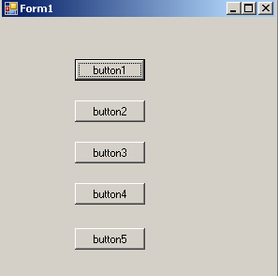

Code:

Using System ;
namespace WindowsApplication2
{
public partial class Form1 : Form
{
public Form1()
{
InitializeComponent();
}
int x, y;
Form f1;
Button b1;
private void button1_Click(object sender, EventArgs e)
{
if (sender == button1)
MessageBox.Show("button1 clicked");
else
MessageBox.Show("button2 clicked");
}

private void button2_Click(object sender, EventArgs e)
{

}

private void button3_Click(object sender, EventArgs e)
{
b1=new Button();
b1.Text="my dynamic button";
b1.Width=200;
x+=20;
y+=20;
b1.Location=new Point(x,y);
this.Controls.Add(b1);

}

private void button4_Click(object sender, EventArgs e)
{
f1 = new Form();
f1.Text = "my new form";
f1.BackColor = Color.Blue;
f1.Show();

}

private void button5_Click(object sender, EventArgs e)
{
f1 = new Form();
f1.Text = "my new form";
f1.BackColor = Color.BlueViolet;
f1.Show();

}

}
}

o/p:

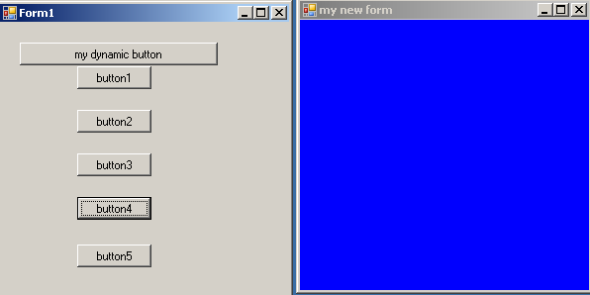

31) W.a.p if user enter the vegetables, fruits, fruits, diary products in
Combobox and in vegetables then takes the tomato,pototo,beans,cabbage in listbox.if user enter the fruits then it takes apple,grape,orange,pineapple,mango in list box. If select that items then corresponding rates display in label?

Form:

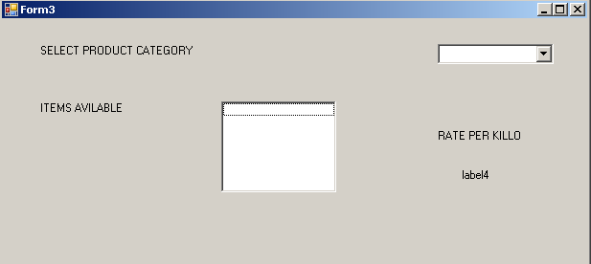

Code:

using System;
namespace WindowsApplication2
{
public partial class Form3 : Form
{
public Form3()
{
InitializeComponent();
}

private void Form3_Load(object sender, EventArgs e)
{
string[] cat ={ "vegetables", "fruits", "grroceries", "diary products" };
foreach (string s in cat)
comboBox1.Items.Add(s);
}
int x;

private void comboBox1_SelectedIndexChanged(object sender, EventArgs e)
{
x=comboBox1.SelectedIndex;
if(x==0)
{
listBox1.Items.Clear();
string[] v ={ "tomoto", "pototo", "beans", "cabbage" };
foreach (string s in v)
listBox1.Items.Add(s);
}
else
if(x==1)
{
listBox1.Items.Clear();
string[] f ={ "apple", "grape", "orange", "pinepple", "mango" };
foreach (string s in f)
listBox1.Items.Add(s);
}
else
if(x==2)
{
listBox1.Items.Clear();
string[] g ={ "rice", "wheat", "sugar", "greengram", "oil" };
foreach(string s in g)
listBox1.Items.Add(s);
}
else
{
listBox1.Items.Clear();
string[] dp ={ "milk", "ghee", "curds" };
foreach (string s in dp)
listBox1.Items.Add(s);
}
}

private void listBox1_SelectedIndexChanged(object sender, EventArgs e)
{

}

private void listBox1_MouseDown(object sender, MouseEventArgs e)
{
int y=0;
int p=0;
if(x==0)
{
y=listBox1.SelectedIndex;
switch(y)
{
case 0: { p = 5; break; }
case 1: { p = 12; break; }
case 2: { p = 16; break; }
case 3: { p = 13; break; }
}
}
else
if(x==1)
{
y=listBox1.SelectedIndex;
switch(y)
{
case 0: { p = 7; break; }
case 1: { p = 11; break; }
case 2: { p =15; break; }
}
}
else
{
y=listBox1.SelectedIndex;
switch(y)
{
case 0:{p=12;break;}
case 1:{p=15;break;}
case 2:{p=17;break;}
case 3:{p=30;break;}
}
}
label4.Text=p.ToString();
}

}
}

o/p:

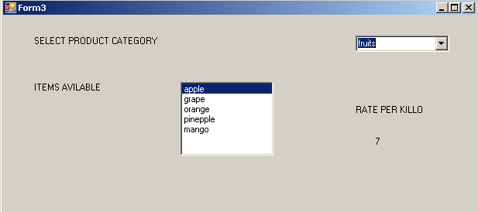

32)W.a.p if user enter the breakfast,lunch,dinner in listbox2 then if select the breakfast then idly,dosa,vadda,uthappam,roti in listbox1 and display the corresponding message. As same as the lunch and dinner?

Form:

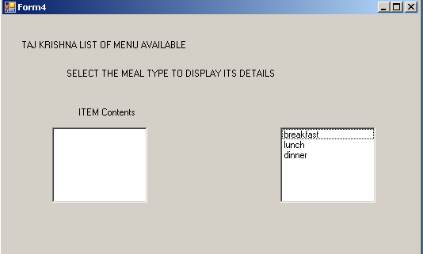

Code:

using System;
namespace WindowsApplication2
{
public partial class Form4 : Form
{
public Form4()
{
InitializeComponent();
}

private void Form4_Load(object sender, EventArgs e)
{
string[] a ={ "breakfast", "lunch", "dinner" };
foreach (string s in a)
listBox1.Items.Add(s);
}

private void listBox1_SelectedIndexChanged(object sender, EventArgs e)
{
int x=listBox1.SelectedIndex;
if(x==0)
{
listBox2.Items.Clear();
label3.Text = "list of items available for breakfast(7:00 to 10:00 am)are follows";
string[] b ={ "idly", "dosa", "vadda", "uthappam", "roti" };
foreach (string s in b)
listBox2.Items
.Add(s);
}
else
if(x==1)
{
listBox2.Items.Clear();
label3.Text = "list of items available for lunch(12:00 noon to 3:00 pm)are as follows";
string[] l ={ "southindia thali", "north indian thali", "splnorth indian thali", "spl south indian thali" };
foreach (string s in l)
listBox2.Items.Add(s);
}
else
{
listBox2.Items.Clear();
label3.Text = "list of items available for dinner(7:00 pm to 11:00 pm) are as follows";
string[] d ={ "andhra bonaza", "italinbuffet", "mexicam buffet", "chinsebuffet" };
foreach (string s in d)
listBox2.Items.Add(s);
}
}
}

}

o/p:

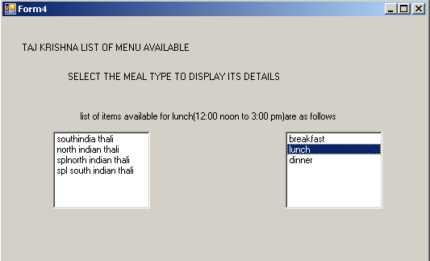

33) W.a.p if user enter the character in textbox1 and click the add button then that character insert into the listbox1.if user enter the character in textbox1 and position in textbox2 then that character insert into the current position in listbox.if remove the character in the textbox3 and selected in list box then that character remove the listbox?

Form:

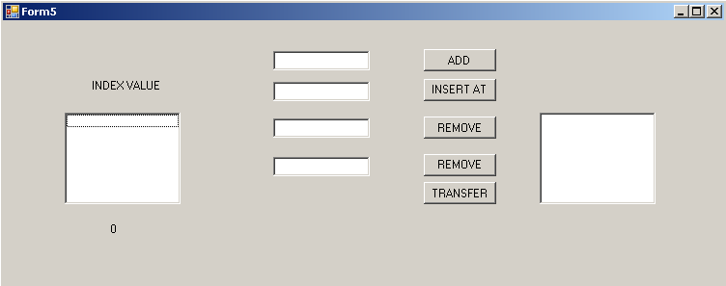

Code:

Using System;
namespace WindowsApplication2
{
public partial class Form5 : Form
{
public Form5()
{
InitializeComponent();
}

private void Form5_Load(object sender, EventArgs e)
{
label2.Text = listBox1.Items.Count.ToString();
}

private void button1_Click(object sender, EventArgs e)
{
if (textBox1.Text != " ")
{
listBox1.Items.Add(textBox1.Text);
label2.Text = listBox1.Items.Count.ToString();
textBox1.Clear();
textBox1.Focus();
}
else
{
MessageBox.Show("cannot insert blank values into the listbox");
textBox1.Focus();
}
}

private void button2_Click(object sender, EventArgs e)
{
if(textBox2.Text!=" "||textBox1.Text!=" ")
{
if(textBox2.Text!=null)
{
if(int.Parse(textBox2.Text)<listBox1.Items.Count)
{
listBox1.Items.Insert(int.Parse(textBox2.Text),textBox1.Text);
textBox1.Clear();
textBox2.Clear();
textBox1.Focus();
label2.Text=listBox1.Items.Count.ToString();
}
else
{
MessageBox.Show("invalid index or item contents");
}
}
}

}

private void button3_Click(object sender, EventArgs e)
{
if (listBox1.Items.Contains(textBox3.Text))
{
listBox1.Items.Remove(textBox3.Text);
}
else
MessageBox.Show("specified element not available in the listbox");
}

private void button4_Click(object sender, EventArgs e)
{
if(int.Parse(textBox4.Text)<listBox1.Items.Count)
{
listBox1.Items.RemoveAt(int.Parse(textBox4.Text));
}
else
MessageBox.Show("invalid index number");
}

private void listBox2_SelectedIndexChanged(object sender, EventArgs e)
{
MessageBox.Show("item selected from the listbox is"+listBox1.SelectedItem+"its index is"+listBox1.SelectedIndex);

}

private void button5_Click(object sender, EventArgs e)
{
listBox2.Items.Add(listBox1.SelectedItem);
listBox1.Items.RemoveAt(listBox1.SelectedIndex);
}
}

}

0/p:

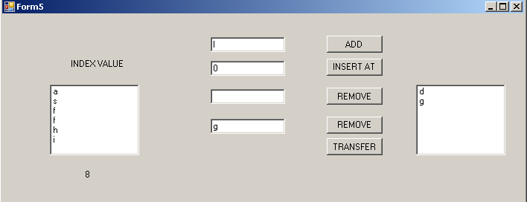

34) W.a.p if user clicks the radiobuttons then to display that corresponding message or displayed?

Form:

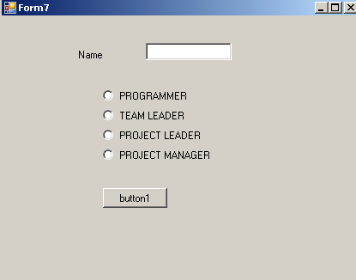

Code:

using System;
namespace WindowsApplication2
{
public partial class Form7 : Form
{
public Form7()
{
InitializeComponent();
}

private void button1_Click(object sender, EventArgs e)
{
if (radioButton1.Checked)
MessageBox.Show(textBox1.Text + " is a programmer");
else
if (radioButton2.Checked)
MessageBox.Show(textBox1.Text + "is a teamleader");
else
if (radioButton3.Checked)
MessageBox.Show(textBox1.Text + " is a project manager");
else
MessageBox.Show(textBox1.Text + "ur on branch with no destigination");

}
}
}

o/p:

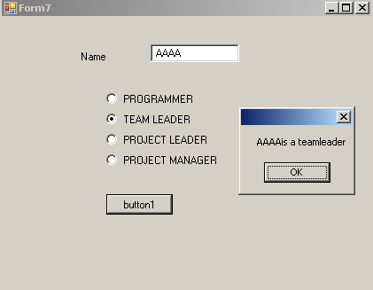

35) W.a.p how to use error provider control and tooltip controls?

Form:

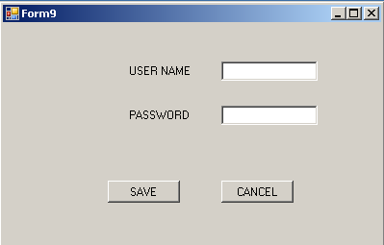

Code:

using System;
namespace WindowsApplication2
{
public partial class Form9 : Form
{
public Form9()
{
InitializeComponent();
}

private void Form9_Load(object sender, EventArgs e)
{
toolTip1.SetToolTip(textBox1, "USERNAME HERE");
toolTip1.SetToolTip(textBox2, "PASSWORD HERE");
}

private void button1_Click(object sender, EventArgs e)
{
if (textBox1.Text == " ")
errorProvider1.SetError(textBox1, "USER NAME CANNOT BE EMPTY");
else
errorProvider1.SetError(textBox1, " ");
if (textBox2.Text == " ")
errorProvider1.SetError(textBox2, "PASSWORD MUST BE PROVIDED");
else
errorProvider1.SetError(textBox2, " ");
}

private void button2_Click(object sender, EventArgs e)
{
textBox1.Clear();
textBox2.Clear();
}

}

}

o/p:

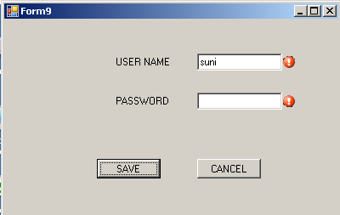

36) W.a.p

Classlibrary1:

Code:

namespace ClassLibrary1
{
public class mathclass
{
int _n1, _n2, _res;
public int firstnumber
{
set { _n1 = value; }
}
public int secondnumber
{
set { _n2 = value; }
}
public int result
{
get { return _res; }
}
public void add()
{
_res = _n1 + _n2;
}

}
}

Form:

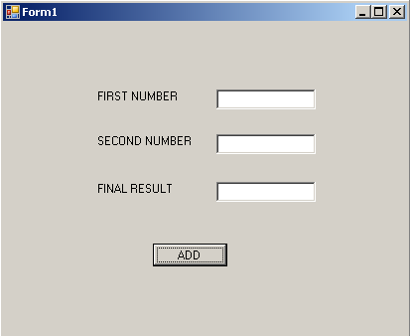

Code:

using classlibrary1;
private void button1_Click(object sender, EventArgs e)
{
mathclass m = new mathclass();
m.firstnumber = int.Parse(textBox1.Text);
m.secondnumber = int.Parse(textBox2.Text);
m.add();
textBox3.Text = m.result.ToString();

}

o/p:

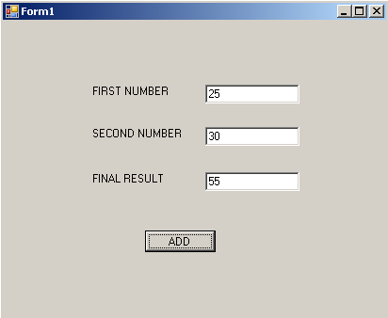

37)

Classlibrary type:

Code:

namespace cl2
{
public class stuclass1
{

int _rno, _m1, _m2;
public int physics
{
set { _m2 = value; }
}
public int maths
{
set { _m1 = value; }
}
public int rollno
{
set{_rno = value;}
}
string _sname,_gr;
public string grade
{
get { return _gr; }
}
public string stuname
{
set { _sname = value; }
}
float _tot, _avg;
public float avgmks
{
get { return _avg; }
}

public float totmks
{
get { return _tot; }

}
public void evalvate()
{
_tot = _m1 + _m2;
_avg=_tot/2;
if (_m1 < 35 || _m2 < 35)
_gr = "FAIL";
else
if (_avg >= 70)
_gr = "distinction";
else
if (_avg >= 60 && _avg < 70)
_gr = "FIRST";
else
if (_avg >= 50 && _avg < 60)
_gr = "SECOND";
else
if (_avg >= 40 && _avg < 50)
_gr = "THIRD";
else
_gr = "pass";
}

}
}

Form:

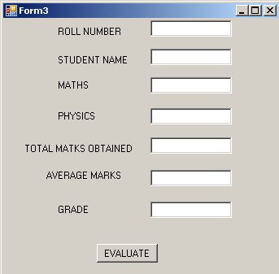

Code:

uing cl2

private void button1_Click(object sender, EventArgs e)
{
stuclass1 s = new stuclass1();
s.maths = int.Parse(textBox3.Text);
s.physics = int.Parse(textBox4.Text);
s.evalvate();
textBox5.Text = s.totmks.ToString();
textBox6.Text = s.avgmks.ToString();
textBox7.Text = s.grade;

}

o/p:

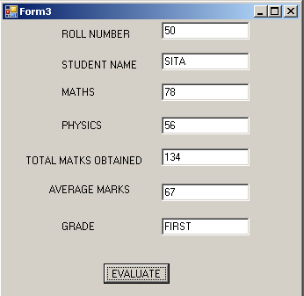

38)

classlibrarytype:

code:

namespace serviceclasslibrary1
{
public class serviceclass
{
string _name;
string _work;
int _empno;
public int empno
{
set { _empno = value; }
get { return _empno; }
}
public string name
{
set { _name = value; }
get { return _name; }

}
public string workingas
{
set { _work = value; }
get { return _work; }
}

Form:

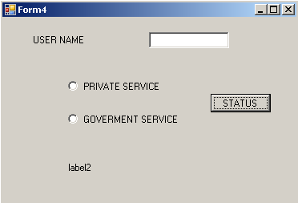

Code:

using serviceclasslibrary
namespace WindowsApplication4
{
public partial class Form4 : Form
{
public Form4()
{
InitializeComponent();
}

private void button1_Click(object sender, EventArgs e)
{
serviceclass obj = new serviceclass();
obj.name = textBox1.Text;
if (radioButton1.Checked)
{
obj.workingas = "private employee";
}
else
{
obj.workingas = " government employee";
}
label2.Text = obj.name + " is working as " + obj.workingas;

}
}
}

o/p:

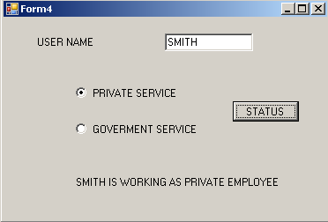

ADO.NET

40) Write a program to store the student details into the database using sqlserver ?

Form:

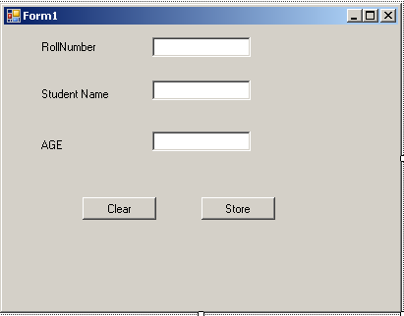

Code:
using System.Data.SqlClient;

namespace psndatabase
{
public partial class Form1 : Form
{
public Form1()
{
InitializeComponent();
}

private void button1_Click(object sender, EventArgs e)
{
textBox1.Clear();
textBox2.Clear();
textBox3.Clear();
}
SqlConnection con;
SqlCommand cmd;
private void button2_Click(object sender, EventArgs e)
{
string sqlstmt;
con=new SqlConnection ("Integrated Security=SSPI;Persist Security Info=False;Initial Catalog=DOTNET;Data Source=DOTNET");
sqlstmt = "INSERT INTO STUD VALUES("+textBox1.Text+",'"+textBox2.Text+"',"+textBox3.Text.ToString ()+")";
cmd = new SqlCommand(sqlstmt, con );

con.Open();
int res = cmd.ExecuteNonQuery();
con.Close ();
if (res > 0)
MessageBox.Show("record is inserted into database sucessfully");
else
MessageBox.Show ("record is not inserted into database stud");
}
}
}

O/P:

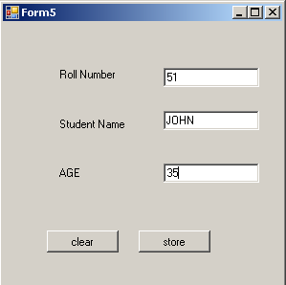

41)

Form:

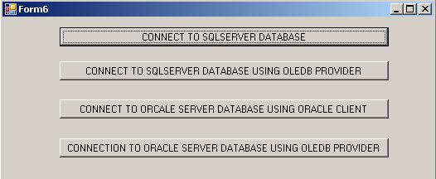

Code:

using System.Data.SqlClient;
using System.Data.OleDb;

namespace WindowsApplication4
{
public partial class Form6 : Form
{
SqlConnection con;
OleDbConnection olecon;

public Form6()
{
InitializeComponent();
}

private void button1_Click(object sender, EventArgs e)
{
con = new SqlConnection("Integrated Security=SSPI;Persist Security Info=False;Initial Catalog=DNDB;Data Source=SYS19");
con.Open();
MessageBox.Show("connection established witth sqlserver");
MessageBox.Show("sqlserver instance name =" + con.DataSource);
MessageBox.Show("sqlcurrent state of the connection with sqlserver db=" + con.State);
con.Close();
MessageBox.Show("state of the connection with sqlserverdb after closeing the connection=" + con.State);
}

private void button2_Click(object sender, EventArgs e)
{
olecon = new OleDbConnection("Provider=SQLOLEDB.1;Integrated Security=SSPI;Persist Security Info=False;Initial Catalog=DNDB;Data Source=SYS19");
olecon.Open();
MessageBox.Show("connection established with sqlserver");
MessageBox.Show("sqlserver instance name="+olecon.DataSource);
MessageBox.Show("sqlserverdatabasename=" + olecon.Database);
MessageBox.Show("current state of the connection with sqlserver db=" + olecon.State);
olecon.Close();
MessageBox.Show("state of the connection with sqlserverdb after closeing the connection=" + olecon.State);
}

private void button3_Click(object sender, EventArgs e)
{
olecon = new OleDbConnection("Integrated Security=SSPI;Persist Security Info=False;Initial Catalog=DNDB;Data Source=SYS19");
olecon.Open();
MessageBox.Show("connection established with sqlserver");
MessageBox.Show("sqlserver instance name=" + olecon.DataSource);
MessageBox.Show("sqlserverdatabasename=" + olecon.Database);
MessageBox.Show("current state of the connection with sqlserver db=" + olecon.State);
olecon.Close();
MessageBox.Show("state of the connection with sqlserverdb after closeing the connection=" + olecon.State);
}

private void button4_Click(object sender, EventArgs e)
{
olecon = new OleDbConnection("Provider=ORACLEOLEDB.1;Integrated Security=SSPI;Persist Security Info=False;Initial Catalog=DNDB;Data Source=SYS19");
olecon.Open();
MessageBox.Show("connection established with sqlserver");
MessageBox.Show("sqlserver instance name=" + olecon.DataSource);
MessageBox.Show("sqlserverdatabasename=" + olecon.Database);
MessageBox.Show("current state of the connection with sqlserver db=" + olecon.State);
olecon.Close();
MessageBox.Show("state of the connection with sqlserverdb after closeing the connection=" + olecon.State);

}

}
}

O/P:

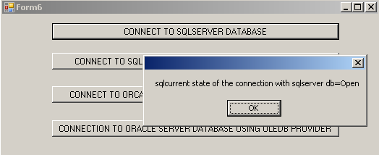

42)

Form:

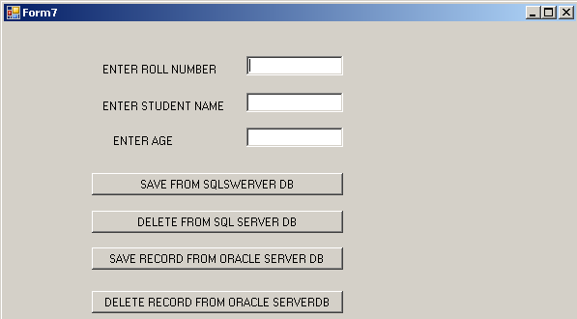

Code:

using System.Data.oracleclient;

namespace WindowsApplication4
{
public partial class Form7 : Form
{
SqlConnection con;
SqlCommand cmd;
string sqlstmt;
public Form7()
{
InitializeComponent();
}

private void button1_Click(object sender, EventArgs e)
{
con = new SqlConnection("Integrated Security=SSPI;Persist Security Info=False;Initial Catalog=DNDB;Data Source=SYS19");
con.Open();
sqlstmt="insert into stutab values("+int.Parse(textBox1.Text)+", '"+(textBox2.Text.ToString())+"',"+int.Parse(textBox3.Text)+")";
cmd = new SqlCommand(sqlstmt, con);
MessageBox.Show("SQL STATEMENT EXECUTE ON DB ---" + sqlstmt.ToString());
cmd.ExecuteNonQuery();
con.Close();
MessageBox.Show("RECORD INSERT INTO SQLDB");

}

private void button2_Click(object sender, EventArgs e)
{
con = new SqlConnection("Integrated Security=SSPI;Persist Security Info=False;Initial Catalog=DNDB;Data Source=SYS19");
sqlstmt = "delete from stutab where rno=" + int.Parse(textBox1.Text);
cmd = new SqlCommand(sqlstmt, con);
con.Open();
int x = cmd.ExecuteNonQuery();
con.Close();
if (x == 0)
MessageBox.Show("no record found in the db matching with the given rollnumber");
else
MessageBox.Show("no: of records deleted=" + x.ToString());
}

private void button3_Click(object sender, EventArgs e)
{
con = new oracleConnection("password=tiger;userid=scott;persist security info=true");
ocon.open();
sqlstmt = "insert into stutab values(" + int.Parse(textBox1.Text) + ",'" + textBox2.Text + "'," + int.Parse(textBox3.Text) + ")";
ocmd = new oracle.command(sqlstmt, ocon);
MessageBox.Show("sqlstmt executed on the db---" + sqlstmt.ToString());
ocmd.executenonquerey();
ocon.close();
MessageBox.Show("record inserted into oracle db");
}

private void button4_Click(object sender, EventArgs e)
{
con = new oracleConnection("password=tiger;userid=scott;persist security info=true");
sqlstmt = "delete from stutab where rno=" + int.Parse(textBox1.Text);
ocmd = new SqlCommand(sqlstmt, ocon);
ocon.Open();
int x = cmd.ExecuteNonQuery();
ocon.Close();
if (x == 0)
MessageBox.Show("no record found in the db matching with the given rollnumber");
else
MessageBox.Show("no: of records deleted=" + x.ToString());

}

}
}
O/P:

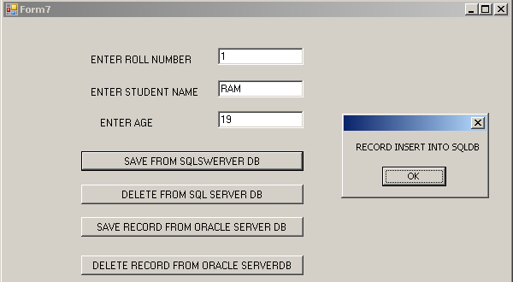

43)

Form:

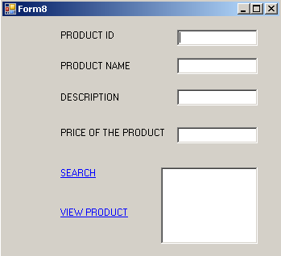

Code:

using System.Data.SqlClient;

namespace WindowsApplication4
{
public partial class Form8 : Form
{
SqlConnection scon;
SqlCommand scmd;
string sqlstmt;
public Form8()
{
InitializeComponent();
}

private void linkLabel1_LinkClicked(object sender, LinkLabelLinkClickedEventArgs e)
{
scon = new SqlConnection("Integrated Security=SSPI;Persist Security Info=False;Initial Catalog=DNDB;Data Source=SYS19");
sqlstmt = "select * from products where pid=" + int.Parse(textBox1.Text);
scmd = new SqlCommand(sqlstmt, scon);
scon.Open();
SqlDataReader dr = scmd.ExecuteReader();
if (dr.Read())
{
textBox2.Text = dr[1].ToString();
textBox3.Text = dr[2].ToString();
textBox4.Text = dr[3].ToString();
}
else
MessageBox.Show("PRODUCT WITH GIVEN ID NOT FOUND"); ;
dr.Close();
scon.Close();

}

private void linkLabel2_LinkClicked(object sender, LinkLabelLinkClickedEventArgs e)
{
scon = new SqlConnection("Integrated Security=SSPI;Persist Security Info=False;Initial Catalog=DNDB;Data Source=SYS19");
sqlstmt = "select pid from products";
scmd = new SqlCommand(sqlstmt, scon);
scon.Open();
SqlDataReader dr = scmd.ExecuteReader();
while (dr.Read())
{
listBox1.Items.Add(dr[0].ToString());
}
dr.Close();
scon.Close();

}

private void listBox1_SelectedIndexChanged(object sender, EventArgs e)
{

}

private void listBox1_Click(object sender, EventArgs e)
{
scon=new SqlConnection("Integrated Security=SSPI;Persist Security Info=False;Initial Catalog=DNDB;Data Source=SYS19");
sqlstmt="select * from products where pid="+listBox1.SelectedItem.ToString();
scmd=new SqlCommand(sqlstmt,scon);
scon.Open();
SqlDataReader dr = scmd.ExecuteReader();
dr.Read();
textBox1.Text = dr[0].ToString();
textBox2.Text = dr[1].ToString();
textBox3.Text = dr[2].ToString();
textBox4.Text = dr[3].ToString();
dr.Close();
scon.Close();

}
}
}

O/P:

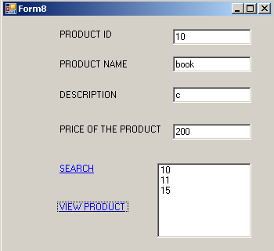

44) Write a program store the student details to newly added column called gender by using following form?(gender as group box)

Form:
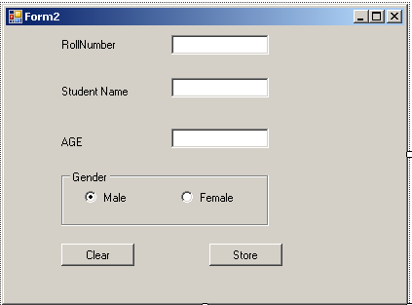

using System.Data.SqlClient;

namespace psndatabase
{
public partial class Form2 : Form
{
public Form2()
{
InitializeComponent();
}

private void button1_Click(object sender, EventArgs e)
{
textBox1.Clear();
textBox2.Clear();
textBox3.Clear();

}
SqlConnection con;
SqlCommand cmd;

private void button2_Click(object sender, EventArgs e)
{
string gen;
string sqlstmt;
gen = "male";
if (radioButton2.Checked)
{
gen = "female";
}
con = new SqlConnection("Integrated Security=SSPI;Persist Security Info=False;Initial Catalog=DOTNET;Data Source=DOTNET");
sqlstmt = "INSERT INTO STUD VALUES(" + textBox1.Text + ",'" + textBox2.Text + "'," + textBox3.Text.ToString() + ",'"+gen.ToString() +"'" +")";
cmd = new SqlCommand(sqlstmt, con);

con.Open();
int res = cmd.ExecuteNonQuery();
con.Close();
if (res > 0)
MessageBox.Show("record is inserted into database sucessfully");
else
MessageBox.Show("record is not inserted into database stud");
}
}
}

O/P:

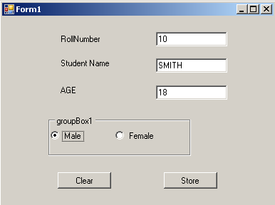

45)

Form:

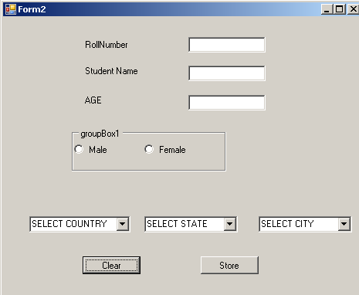

Code:

string gen;
gen = "male";
if (radioButton2.Checked)
{
gen = "female";
}
string sqlstmt;
con = new SqlConnection("Integrated Security=SSPI;Persist Security Info=False;Initial Catalog=DOTNET;Data Source=DOTNET");
sqlstmt = "INSERT INTO STUD VALUES(" + textBox1.Text + ",'" + textBox2.Text + "'," + textBox3.Text.ToString() + ",'" + gen.ToString() + "'" + ",'"+country.ToString ()+"','"+state.ToString() +"','"+city.ToString ()+"'"+ ")";
cmd = new SqlCommand(sqlstmt, con);

con.Open();
int res = cmd.ExecuteNonQuery();
con.Close();
if (res > 0)
MessageBox.Show("record is inserted into database sucessfully");
else
MessageBox.Show("record is not inserted into database stud");
}

string country;
private void comboBox1_SelectedIndexChanged(object sender, EventArgs e)
{
int i;

comboBox2.Items.Clear();
comboBox3.Items.Clear();
i = comboBox1.SelectedIndex;
country = comboBox1.SelectedItem.ToString();
switch (i)
{
case 0: comboBox2.Items.Clear();
string[] sti ={ "AP", "CHENNAI", "KARANATAKA" };
comboBox2.Items.AddRange(sti);
break;
case 1:
comboBox2.Items.Clear();
string[] stc ={ "Beizing", "Chuang" };
comboBox2.Items.AddRange(stc);
break;
case 2:
comboBox2.Items.Clear();
string[] stu ={ "NewYork", "CHICAGO", "NEWJERSY" };
comboBox2.Items.AddRange(stu);
break;

}

}

private void Form4_Load(object sender, EventArgs e)
{

string[] cn ={ "INDIA", "CHINA", "USA" };
comboBox1.Items.AddRange(cn);

}
string state;

private void comboBox2_SelectedIndexChanged(object sender, EventArgs e)
{
int i, j;
comboBox3.Items.Clear();
i = comboBox1.SelectedIndex;
j = comboBox2.SelectedIndex;
state = comboBox2.SelectedItem.ToString();
if( (i==0) &&(j<int.Parse (comboBox2.Items.Count .ToString ())))
{
switch(j)
{
case 0:
comboBox3.Items.Clear();
string[] cta ={ "Hyderabad", "Rajahmundry", "Vizag", "Guntur" };
comboBox3.Items.AddRange(cta);
break;
case 1:
comboBox3.Items.Clear();
string[] ctc ={ "Koimbatoor", "Tirichhi", "Selam", "Chennai" };
comboBox3.Items.AddRange(ctc);
break;
case 2:
comboBox3.Items.Clear();
string[] ctk ={ "Manglore", "Jayanagar", "BTM", "Silicon valley" };
comboBox3.Items.AddRange(ctk);
break;
}
}
if ((i == 1) && (j < int.Parse(comboBox2.Items.Count.ToString())))
{
switch(j)
{
case 1:
comboBox3.Items.Clear();
string[] ctcg ={ "cheyan", "jeang", "biyang", "siyong" };
comboBox3.Items.AddRange(ctcg);
break;
case 0:
comboBox3.Items.Clear();
string[] ctbg ={ "seizing", "Meizing", "Peizing", "BYZING" };
comboBox3.Items.AddRange(ctbg);
break;

}
}
if ((i == 2) && (j < int.Parse (comboBox2.Items.Count.ToString()) ))
{
switch(j)
{
case 0:
comboBox3.Items.Clear();
string[] ctnew ={ "york", "new", "park", "silk" };
comboBox3.Items.AddRange(ctnew);
break;
case 1:
comboBox3.Items.Clear();
string[] ctchic ={ "chci", "Tichi", "cago", "gochi" };
comboBox3.Items.AddRange(ctchic);
break;
case 2:
comboBox3.Items.Clear ();
string[] ctjersy ={ "jersy", "newz", "mercy", "cursy" };
comboBox3.Items.AddRange(ctjersy);
break;
}
}
}
string city;
private void comboBox3_SelectedIndexChanged(object sender, EventArgs e)
{
city = comboBox3.SelectedItem.ToString();
}
}
}

46)

